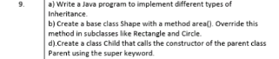
=====================================================================================

COMMAND:
InheritanceDemo
// Base class
class Animal {
void eat() {
System.out.println("Animal is eating");
}
}

// Single Inheritance
class Dog extends Animal {
void bark() {
System.out.println("Dog is barking");
}
}

// Multilevel Inheritance
class Puppy extends Dog {
void weep() {
System.out.println("Puppy is weeping");
}
}

// Hierarchical Inheritance
class Cat extends Animal {
void meow() {
System.out.println("Cat is meowing");
}
}

public class InheritanceDemo {
public static void main(String[] args) {

// Single Inheritance
Dog d = new Dog();
d.eat();
d.bark();

System.out.println();

// Multilevel Inheritance
Puppy p = new Puppy();
p.eat();
p.bark();
p.weep();

System.out.println();

// Hierarchical Inheritance
Cat c = new Cat();
c.eat();
c.meow();
}
}

ShapeDemo
// Base class
class Shape {
void area() {
System.out.println("Area of shape");
}
}

// Subclass Rectangle
class Rectangle extends Shape {
int length = 10;
int width = 5;

void area() {
int result = length * width;
System.out.println("Area of Rectangle: " + result);
}
}

// Subclass Circle
class Circle extends Shape {
double radius = 7;

void area() {
double result = 3.14 * radius * radius;
System.out.println("Area of Circle: " + result);
}
}

public class ShapeDemo {
public static void main(String[] args) {

Shape s;

s = new Rectangle();
s.area();

s = new Circle();
s.area();
}
}

SuperDemo
class Parent {
Parent() {
System.out.println("Parent class constructor called");
}
}

class Child extends Parent {
Child() {
super(); // Calls Parent constructor
System.out.println("Child class constructor called");
}
}

public class SuperDemo {
public static void main(String[] args) {
Child obj = new Child();
}
}

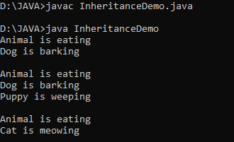
OUTPUT:

